**EXPERIMENT 6**

**Title:** Designing 3D objects using blender.

**Objective:** To design a three-dimensional hut using blender.

**Theory:**

Blender is the free and open source 3D creation suite. It supports the entirety of the 3D pipeline—modelling, rigging, animation, simulation, rendering, compositing and motion tracking, video editing and 2D animation pipeline. The latest version can be found on www.blender.org

**Procedure:**

**Step 1:** Open Blender

**Step 2:** Create a blank file and delete the default cube.

**Step 3:** Add a plane and scale it to an average area of a hut, using Shift+A>S.

**Step 4:** Switch to edit mode using TAB.

**Step 5:** Add some loop cuts using CTRL+R, to create a division of rooms inside the hut. Loop cuts are needed to be added with respect to X and Y axis.

**Step 6:** Now delete any one face to bring the plane in L shape and extrude(E) it with respect to the z-axis such that it is equal to the two floors.

**Step 7:** To make a triangular-domed roof, extrude from middle from both ends of the hut. Add a similar plane in between both floors to differentiate between them.

**Step 8:** Now, add some pillars to the HUT by adding a plane first and then by scaling it with respect to z-axis. Now add the same pillar to every corner by just duplicating it. (shift+D)

**Step 9:** To create the roof, add a cylinder apart from the hut. Switch to wireframe mode and select the half of cylinder and delete the vertices. Now duplicate it using (shift+D) and rotate it 180 degree and align both cover each other. Now add an array modifier (x-axis)and increase the number according to the length of the roof. Add a second array modifier (y-axis) and increase the number according to the breadth of roof.

**Step 10:** Add the same to the top of hut by tilting it according to shape of the hut. And add the copy of same to other parts of roof.

**Step 11:** Now add a camera and a light source to it. And arrange the camera to the best fit view.

**Screenshots:**

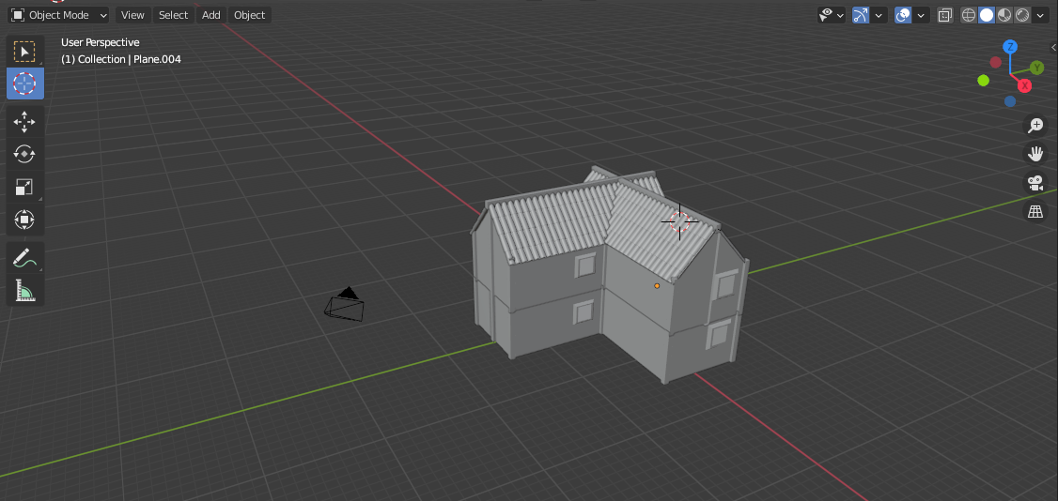

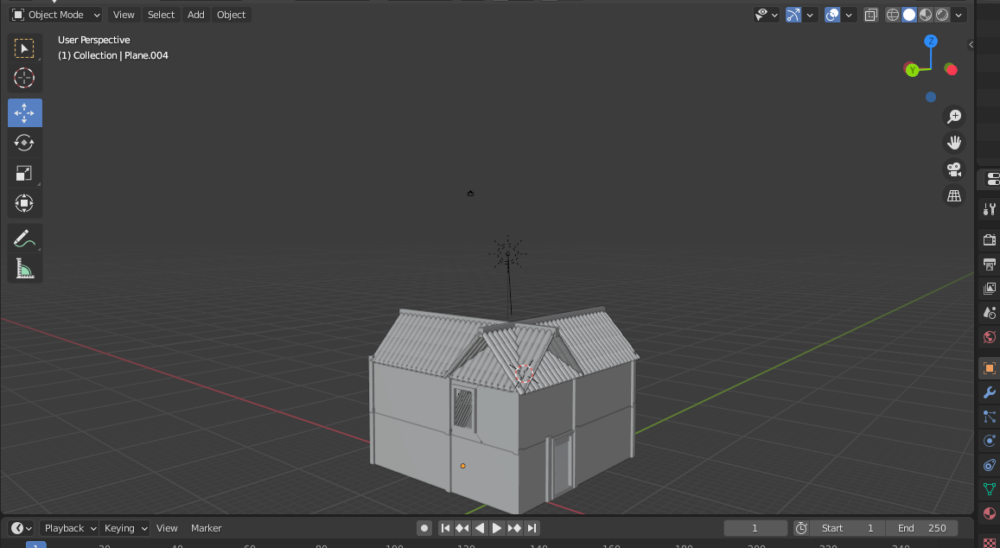

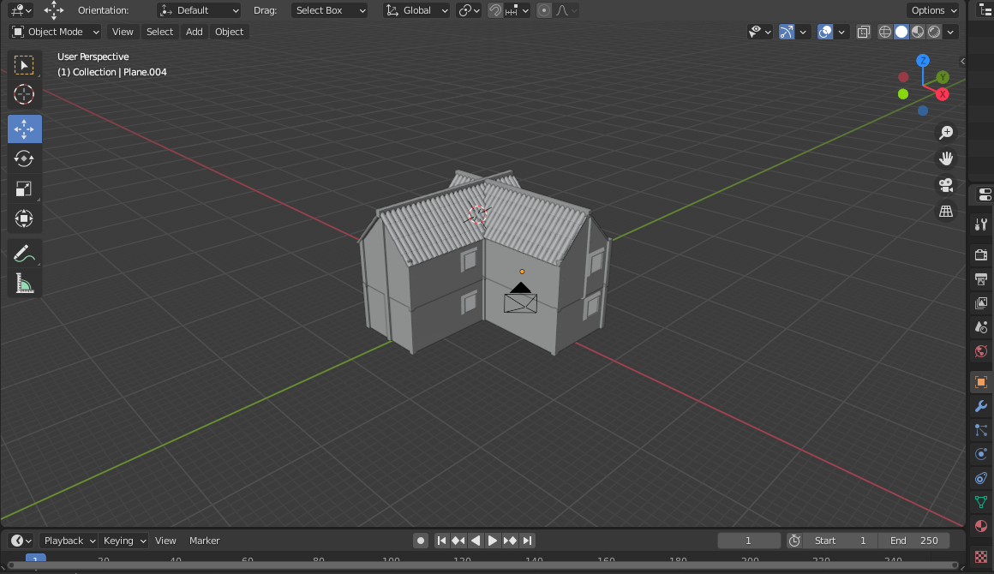

**Link:** [GAT LAB - Experiment 6 (All Files)](https://drive.google.com/drive/folders/1F0n3toGFBxerwLofjWJCbFTGBJn_oL42?usp=sharing)

**Conclusion:** Hence, we have designed a beautiful 3D model of a hut.